

# INT404 ARTIFICIAL INTELLIGENCE

**PROJECT TITLE: VOICE ASSISTANT**

## Name : S.Vijaya Bhaskar Reddy

**Roll No : 34**

**Reg No : 11805918**

**Section : K18JC Submitted to : Sagar Pande sir**

VOICE ASSISTANT

## INTRODUCTION:

Voice assistants are software agents that can interpret human speech and respond via synthesized voices. Apple's Siri, Amazon's Alexa, Microsoft's Cortana, and Google's Assistant are the most popular voice assistants and are embedded in smartphones or dedicated home speakers. Users can ask their assistants questions, control home automation devices and media playback via voice, and manage other basic tasks such as email, to-do lists, and calendars with verbal commands. This column will explore the basic workings and common features of today's voice assistants. It will also discuss some of the privacy and security issues inherent to voice assistants and some potential future uses for these devices.

**Most common Questions regarding Voice Assistant are:**

1. What is a voice assistant?

2.What can voice assistants do?

3.How do voice assistants work?

* Voice assistants are programs on digital devices that listen and respond to verbal commands.  A user can say, “What’s the weather?” and the voice assistant will answer with the weather report for that day and location. They could say, “Tell me story,” and the assistant will jump into a tale. The user could even say, “Order my favorite pizza,” and dinner will be on its way!
* Voice assistants are so easy to use that many people forget to stop and WONDER how they work. How do voice assistants understand us? Is it magic? A Complexity system of codes? An actual person listening on the other end? The answer is less complicated than you might think.
* It all starts with a signal word. Have you ever called a friend’s name to get their attention? Users say the names of their voice assistants for the same reason. They might say, “Hey Siri!” or simply, “Alexa!” Whatever the signal word is, it wakes up the device. It signals to the voice assistant that it should begin paying attention.
* After the voice assistant hears its signal word, it starts recording. The device waits for a pause to know you’ve finished your request. The voice assistant then sends your recorded request over the Internet to its database.
* Once in the database, your request is compared to other requests. It’s split into separate commands your voice assistant can understand. The database then sends these commands back to the voice assistant. Once it receives the commands, the voice assistant knows what to do next. The device might ask a question to make sure it understands what you want. If it thinks it understands, the voice assistant will carry out the task you asked for
* If you’ve ever used a voice assistant, you know all of that happens very quickly! If you say, “Hey Siri! What’s the weather?” Siri reports back to you in seconds. The more directions the devices receive, the better and faster they get at fulfilling our requests
* Voice assistants are improving all the time. They learn the same way people do. Have you ever asked a voice assistant for something and received results you didn’t expect? Each time this happens, the voice assistant learns from its mistake. If you say, “Alexa, play rock music,” and it plays country music, you’ll tell Alexa to stop. That teaches the device that the command it received from its database was wrong. It communicates that with the database and tries to do better next time.

# Conceptual framework:

### Library used:

**1.Speech recognition**

**Voice** or speaker **recognition** is the ability of a machine or program to receive and interpret dictation or to understand and carry out spoken commands. **Voice recognition** has gained prominence and use with the rise of AI and intelligent **assistants**, such as Amazon's Alexa, Apple's Siri and Microsoft's Cortana.

To install: $ pip install SpeechRecognition

### 2**.web browser**

Voice assistants are already starting to gain the ability to control our web browsers. After the voice recognition then it will take to web browser to search in internet.

### 3. **Wikipedia**

### In web browser the user searched things will be open in Wikipedia.

4. **py audio**

PyAudio provides Python bindings for Port Audio, the cross-platform audio I/O library. With PyAudio, you can easily use Python to play and record audio on a variety of platforms.

**Applications :**

1. **Siri** : Siri is the product that put the whole idea of an AI voice assistant on the map. This assistant first shipped with the iPhone 4S and has featured in every Apple mobile device since then. Obviously you can only make use of Siri on Apple hardware, but at the same time Siri isn’t the only game in town on iPhones anymore either.

1. **Google Assistant** : The Google Assistant, despite the rather unimaginative name, is a powerful AI that’s available on just about every Android device on the market. Powered by Google’s powerful algorithms, this software is eerily intelligent.
2. **Cortana** : Cortana is named after the AI character from the Halo series of video games. She’s Microsoft’s answer to Siri and is also integrated with the Windows 10 operating system. Microsoft doesn’t really have a stake in phone hardware anymore with the failure of Windows Phone, so Cortana is available as an app download on both the iOS and Android platforms.
3. **Alexa** : Alexa is the offering from online retail giant Amazon. So it has deep integration with Amazon’s products and services. You can buy anything from groceries to another Alexa smart speaker with just a few words, which is a brilliant business strategy from Mr. Bezos
4. **Bixby** : Like Siri, Bixby is exclusive to one particular hardware platform. In this case, it’s only available on Samsung phones. Some phones that feature Bixby actually have a dedicated physical button to summon this digital servant, which is either a bonus or an irritation, depending on your point of view.
5. **Robin :** Robin has been marketed as the Android equivalent of Siri, but at the same time this if officially beta software. Which means if you give Robin a try you’re helping shape the assistant into what it will one day be.
6. **Lyra Virtual Assistant :** Lyra is one of the most serious contenders when it comes to knocking the top voice assistant products from their pedestals. It’s a truly smart, innovative tool that promises to do great things. If enough people catch on to it.

It’s a cloud-based, multi-platform assistant which you can use on your desktop, laptop, tablet and phone. There are both Android and iOS apps, so most mobile users are covered**.**

## Advantages for using voice assistant:

1. voice assistant can easily lift and make calls without touching your system.
2. can easily open the song u want to play . if u ask.
3. it will make things easy to you like setting alarm, remainders etc.

**Code:**

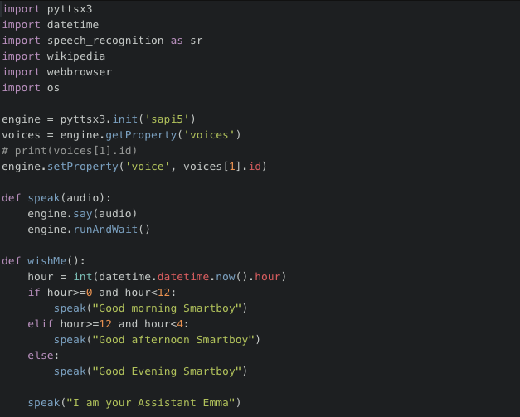

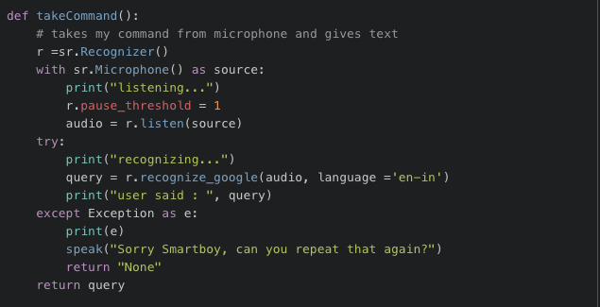

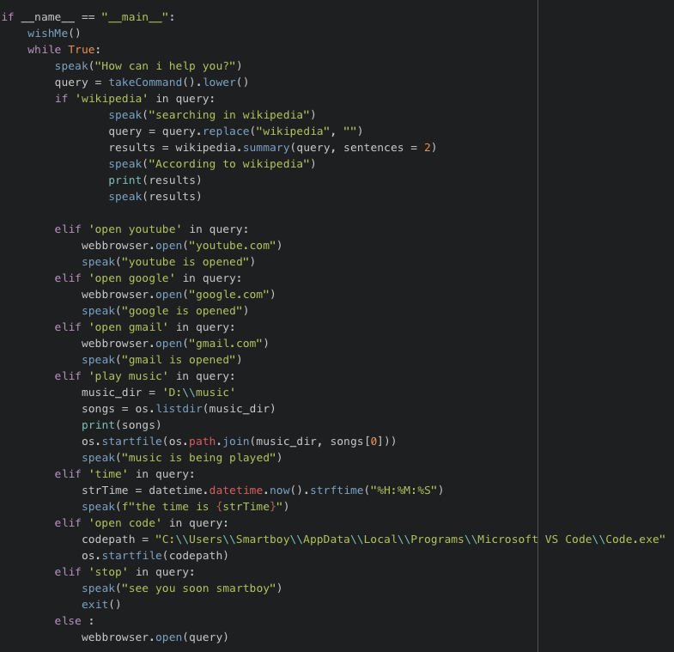

**Conclusion:**

Nowadays voice assistant are developing at a rapid phase and they can found at any home and office’s. this project is for learning and study purpose so in the future I would like to develop it into a fully working prototype.